**202304 IC 115 T01 Web Design Development I**

**WEB PROPOSAL**

What is the name and purpose of the site?

🡪 This site is an e-commerce shoes shopping website which allows users to explore and buy different categories of shoes.

List the website name and the reasons you are creating the site.

🡪 The website name will be HM Shoes and the reason for the creation is to try and give myself hands-on experience of developing a website.

What do you want the site to accomplish?

🡪 The main motive to build this site is to get a greater number of user engagement for those who love to buy shoes online and get a smooth experience of shopping.

Explain the goal you have for the site. Describe what needs to happen for you to consider your site a success.

🡪 The ultimate goal is to build a complete full-featured site with the options of adding, removing and editing the cart for orders and allow users to surf through different categories of shoes and can buy without any hassle.

Who is your target audience?

🡪 The target audience are those who loves to shop online, who has trust on e-commerce shopping and can be from any age group from young generation of students, youths who love to wear trendy sneakers to old age group who can buy comfortable shoes for their daily routine.

Describe your target audience by age, gender, socioeconomic characteristics, and so on.

🡪 The target audience could be from any age and gender as it will have a collection of shoes that are suitable for each age group with the cheapest to high priced and most expensive ones which makes no barrier to get any specific audience.

What opportunity or issue is your site addressing? What do you want the user to do on the site (call to action)

🡪 This site is an example of the current most famous type of website that is an e-commerce website which allows user to buy and sell through online medium of such sites. Users don’t have to physically go to the outlets of the stores for shopping and can just order online with the description and information that are conveyed to them through such websites. Using this type of website any shoe selling company can expand their market by getting orders online.

Note: Your site might be addressing the opportunity of providing information about a topic to others, creating an initial web presence for a company, and so on.

What type of content might be included in your site?

🡪 The site will show the content regarding different categories of shoes for example sneakers, running shoes etc. where users can explore and add them to their cart.

Describe the type of text, graphics, and media you will need for the site.

🡪 This site will require different types of font to make it more representative and the use of different images and colors on different web pages.

List at least two related or similar sites found on the Web.

🡪 There are many such sites which let users to buy shoes online such as

[www.nike.com](http://www.nike.com) [www.adidas.com](http://www.adidas.com) [www.vegnonveg.com](http://www.vegnonveg.com)

**SITE MAP**

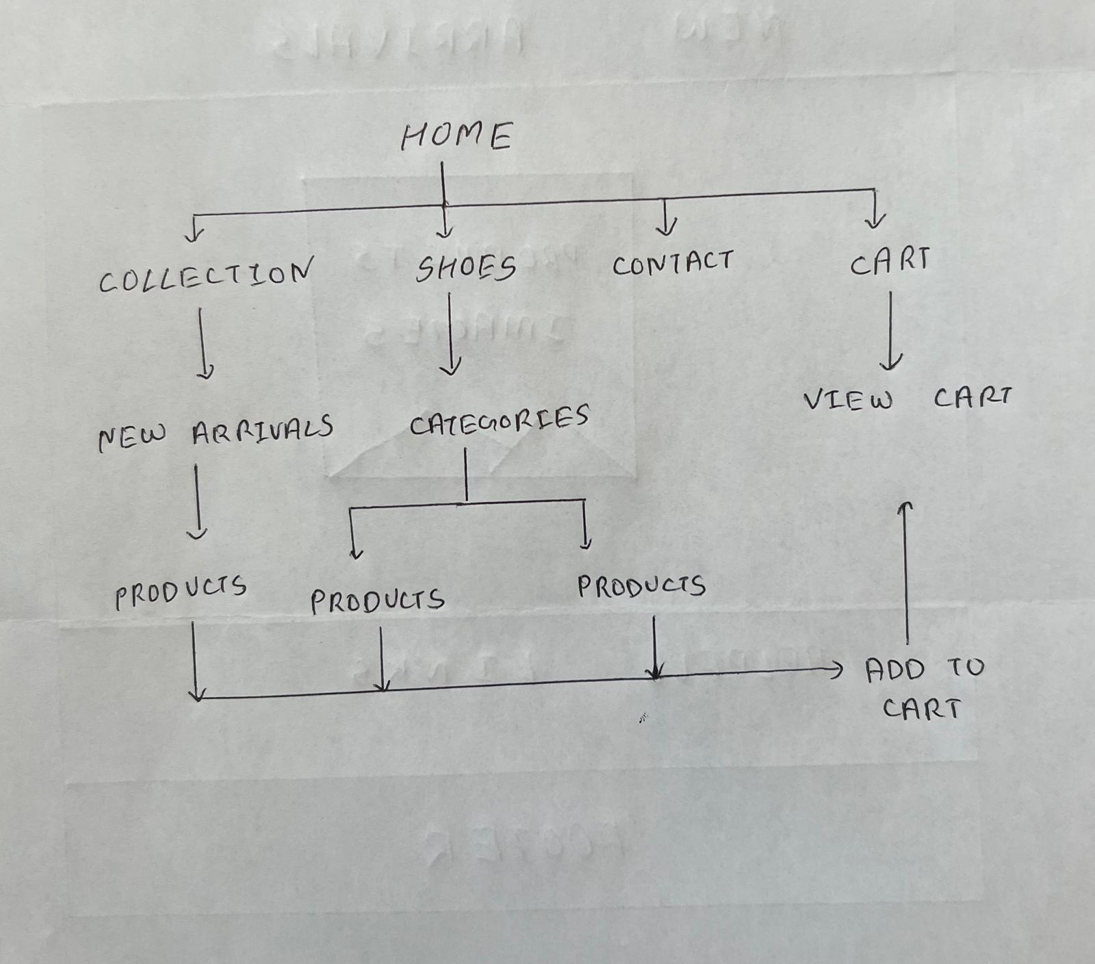

**PAGE LAYOUT**

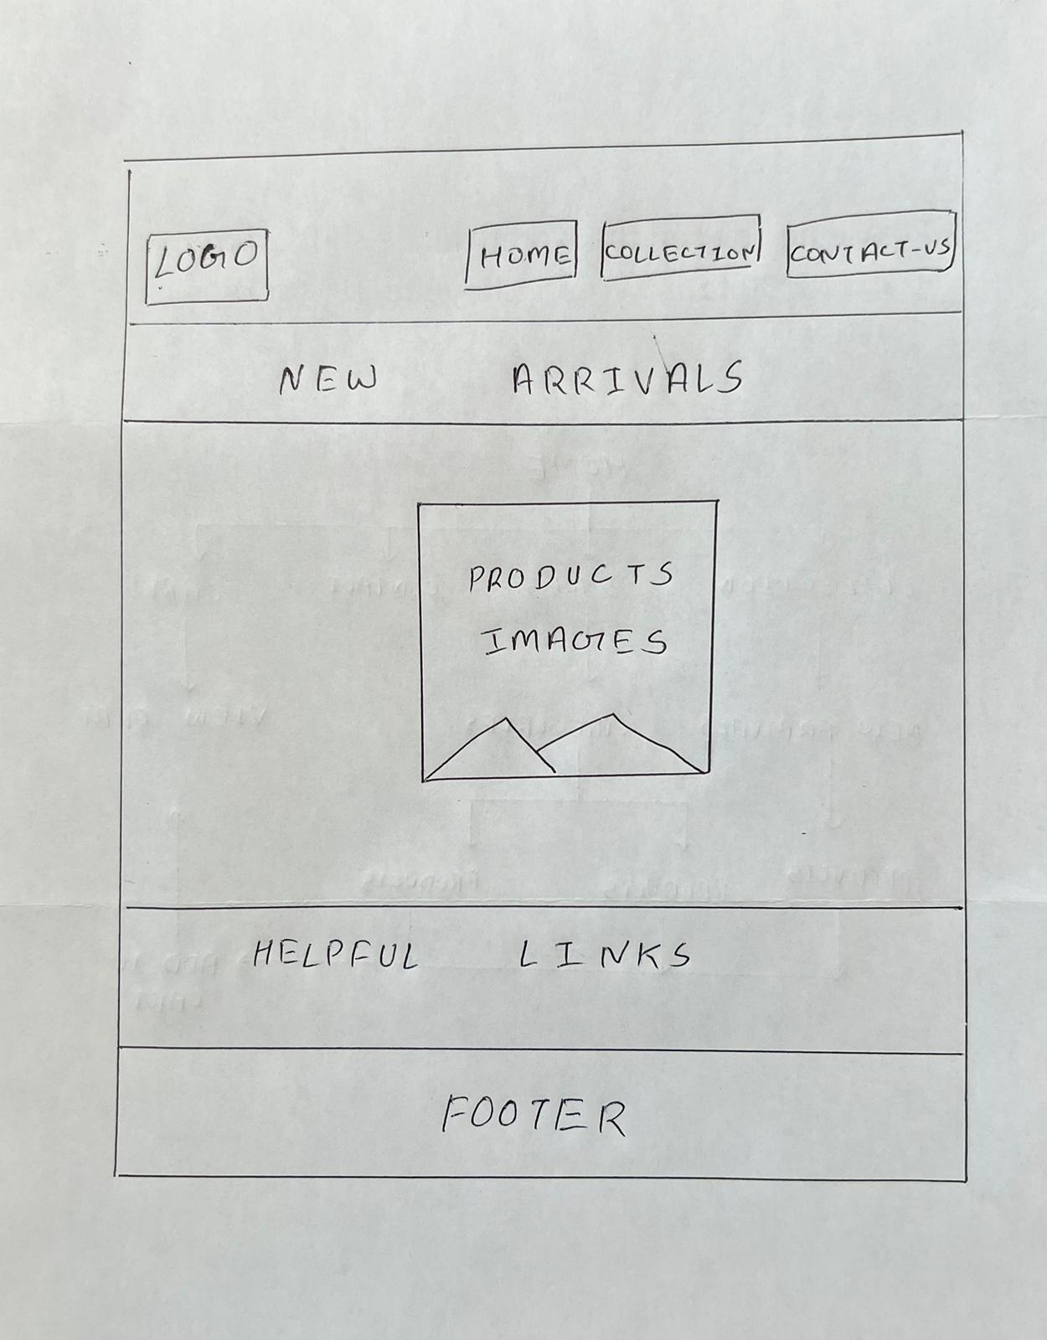

**What results do I want to see?**

Home Page: It will be the index page of the website where user lands at first, it will have a navbar that will take user to different sections like collection, shoes, contact information and cart.

Collection Page: It will display the new arrivals, user can view their description and can also add them to the cart

Shoes Page: It will display all the shoes that are available to buy and can be added to the cart.

Contact Page: This place will have the contact details where user can call and clear any queries or add some feedback.

**What information do I need?**

I will be required to search the different categories of shoes that are available in the market and use some images of different shoes to add it to the collection. Also, might be required to use some small videos to attract more users. In addition to that different web resources to get more information about website development and to solve arriving issues.

**Schedule**

I have started working on the site development and will be showing my progress to the professor every lab and complete it within the due date which will be provided.